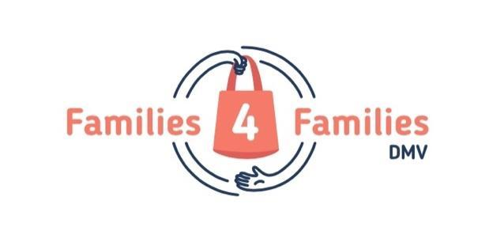

[Address]

[Date]

Dear [Name],

On behalf of our Board of Directors, staff, and student leaders, thank you so much for your generous donation to Families4FamiliesDMV! The compassion and generosity of the [Name] is helping to keep families in need from going hungry.

On [Date], you made a gift of [Item(s)] to our cause. Your generous donation consisted of [Items, if multiple] valued at [Amount].

No goods or services were provided in exchange for your financial donation.

With gratitude,

Amanda Marshall
Founder
Families4FamiliesDMV

Families4Families is a 501(c)(3) nonprofit organization of the Internal Revenue Code (EIN 85-2436333). Your contribution is tax deductible to the extent allowed by law. No goods or services were provided in exchange for your financial donation.

